Mayor’s Office of Employment Development - Local Hiring Law Office
Prism Instructions - How to submit the monthly employment report in Prism
For videos and more information, see our website at the following link: Local Hiring | Mayor's Office of Employment Development
Step 1: Make sure that you have registered for a vendor log in. If you do not have a vendor log in for Prism, follow this link to set up the vendor log in. https://pro.prismcompliance.com/CustomCertApp/ApplicationStart.aspx?j=QRosLEgLhfM%3d&t=200
Step 2: Log in to Prism Compliance using this link. Once on the main screen as seen below, log in using the user name and password created during vendor registration.
https://pro.prismcompliance.com
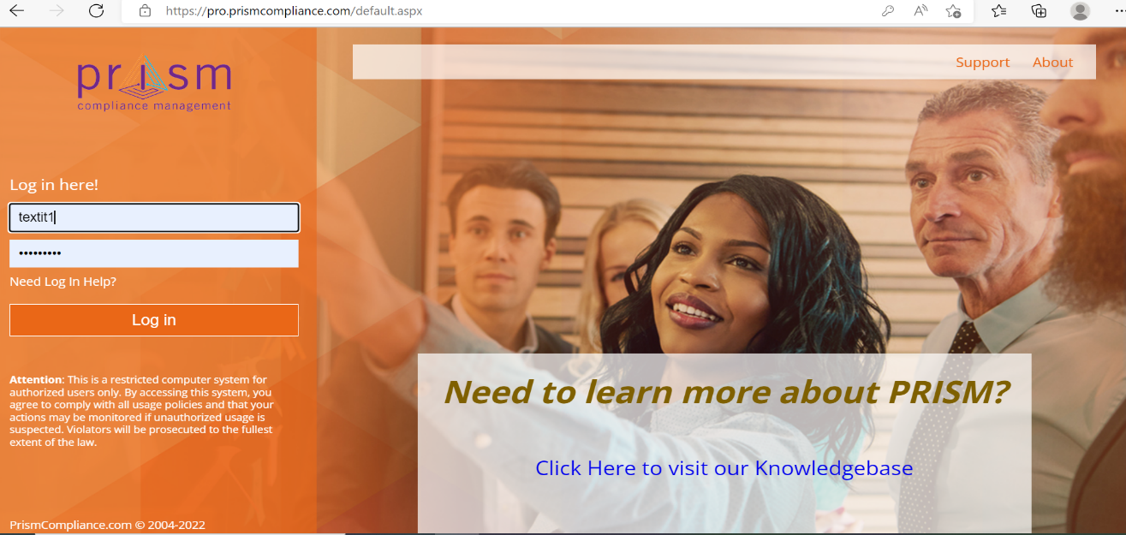
Step 3: Once signed in click the “Labor Compliance” then “Manage Workforce Reports”
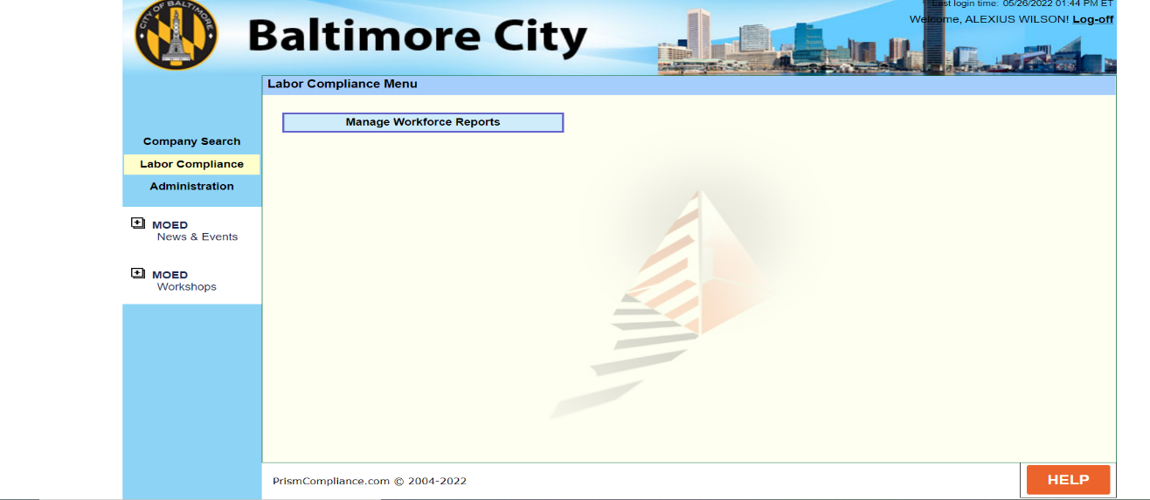
Step 4: The Workforce Menu will show previous submitted monthly employment reports. This is also were the new reports are added. Select “Add Workforce Report” located in the bottom right corner of the screen.
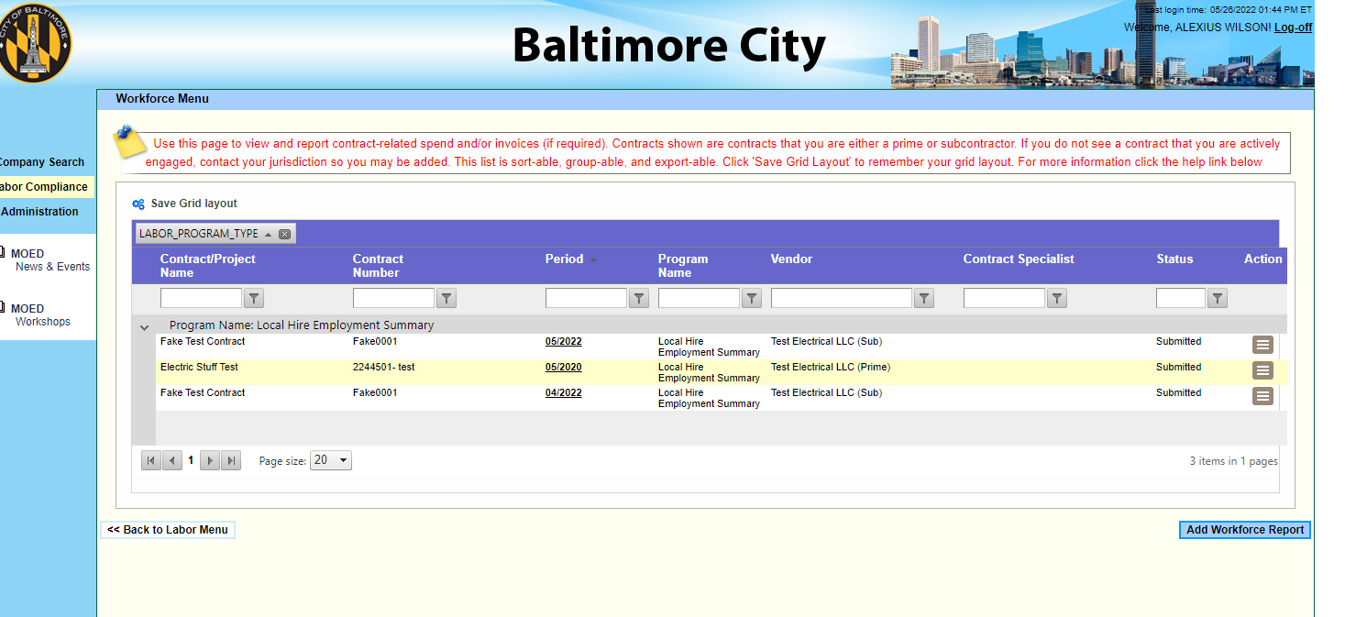

Step 5: Select the contract or project for which the report is being submitted. Follow the instructions in red to complete this section. Once complete click “save”.
If a contract does not appear that you would expect to see, it may mean that you have not completed an employment analysis form or meeting with MOED. Please contact MOED (or your prime contractor if you are a sub) for more information.
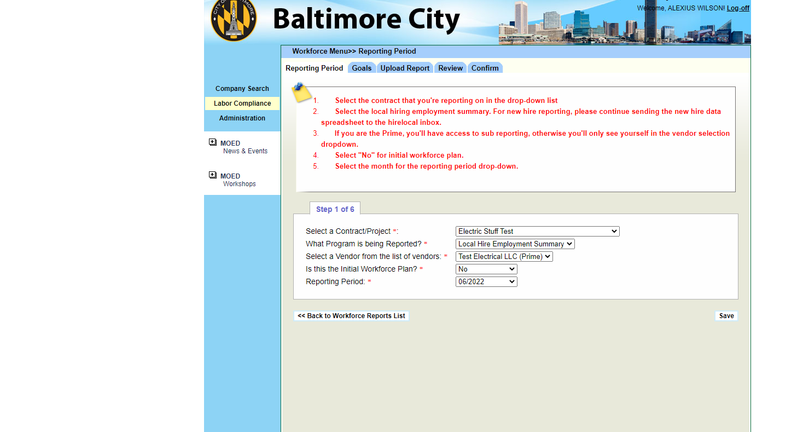

Step 6: From this page click “Continue to Upload Report ”
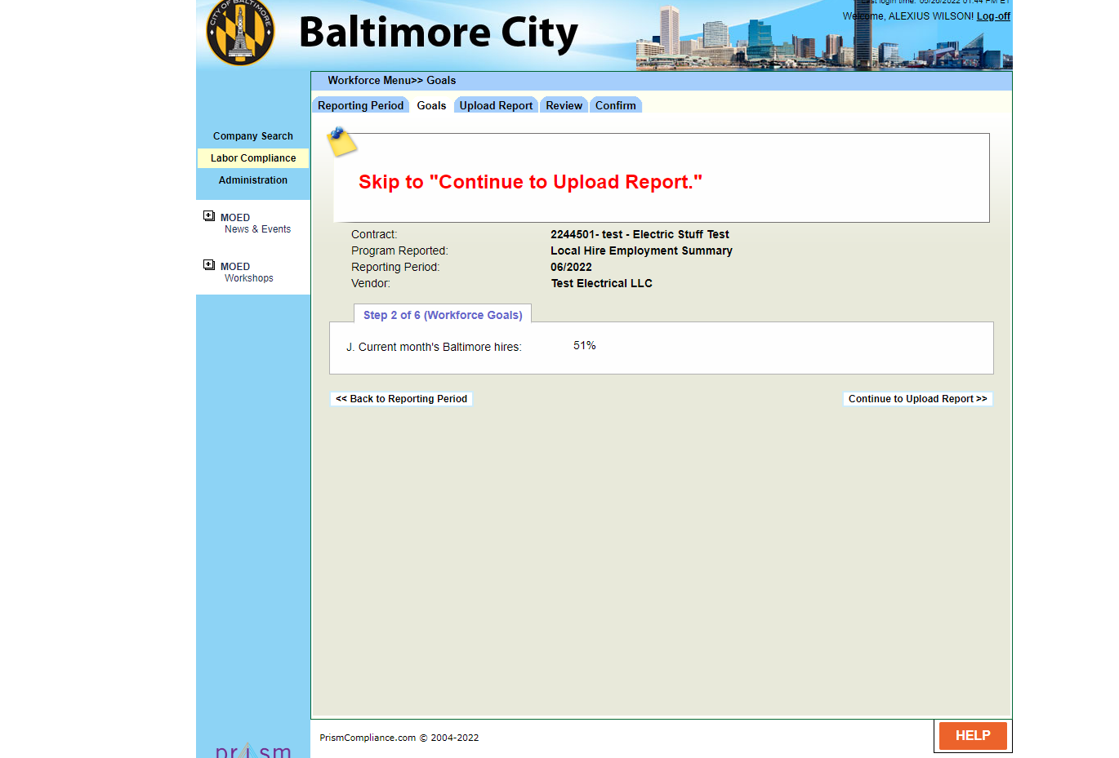

Step 7: Do not utilize the upload reports page. Click continue to review.
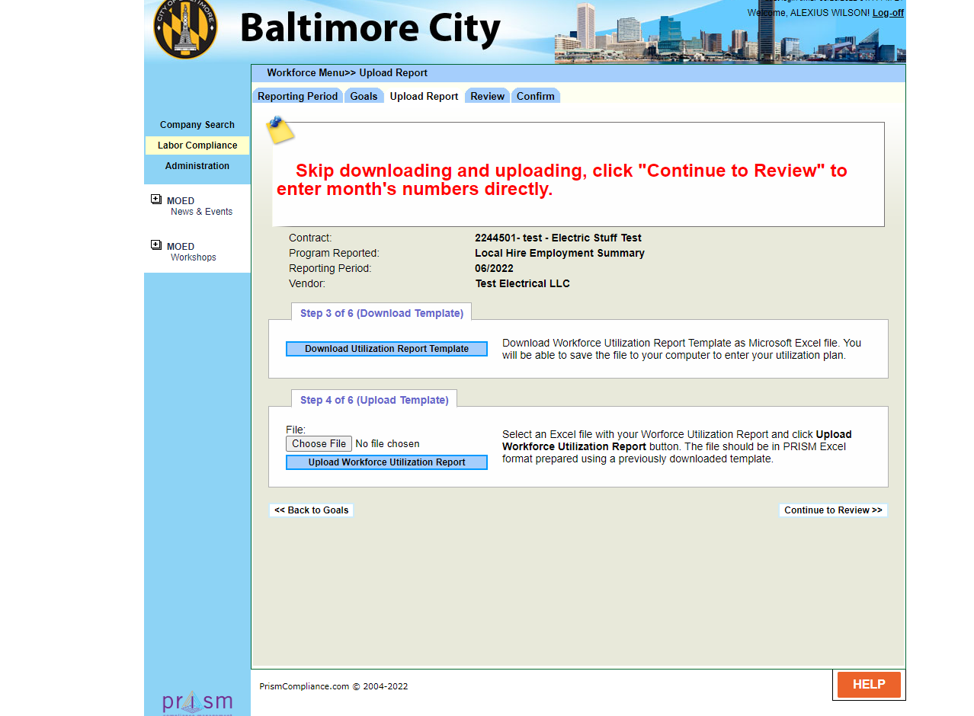

Step 8: Follow the instruction in the upper box titled Employment Report Templet Instruction to complete the workforce report. Click “Add” once all columns are complete then click continue to confirm.
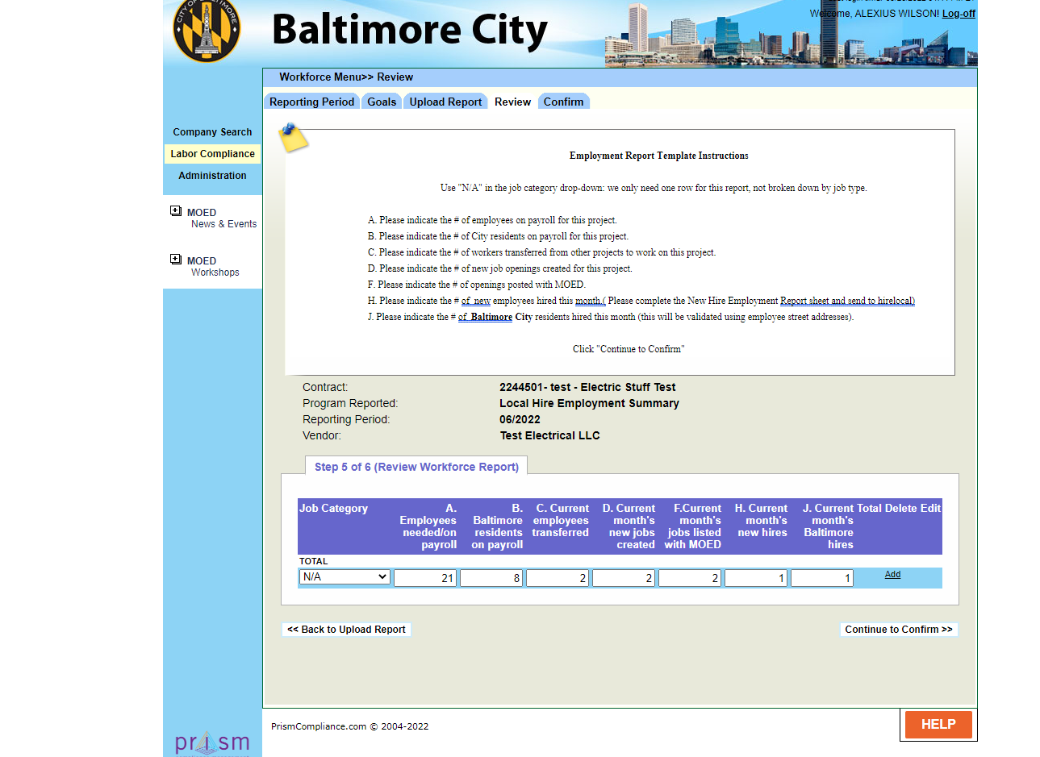
Step 9: Please read the agreement and check the acknowledgement box along with your full name and submit the report.
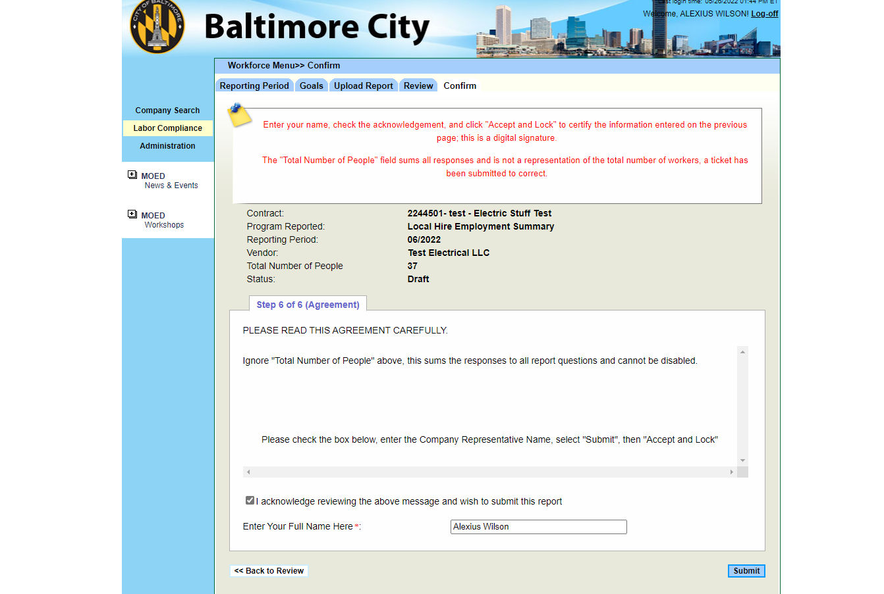

Step 10: In the upper left corner click the Reporting Period Tab.
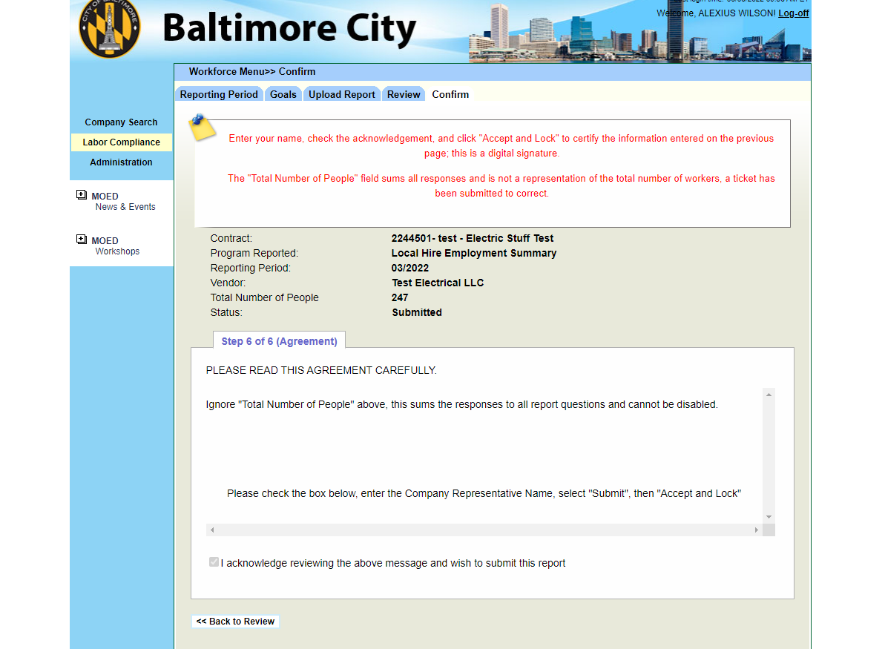
Step 11: Click “Back to Workforce Reports List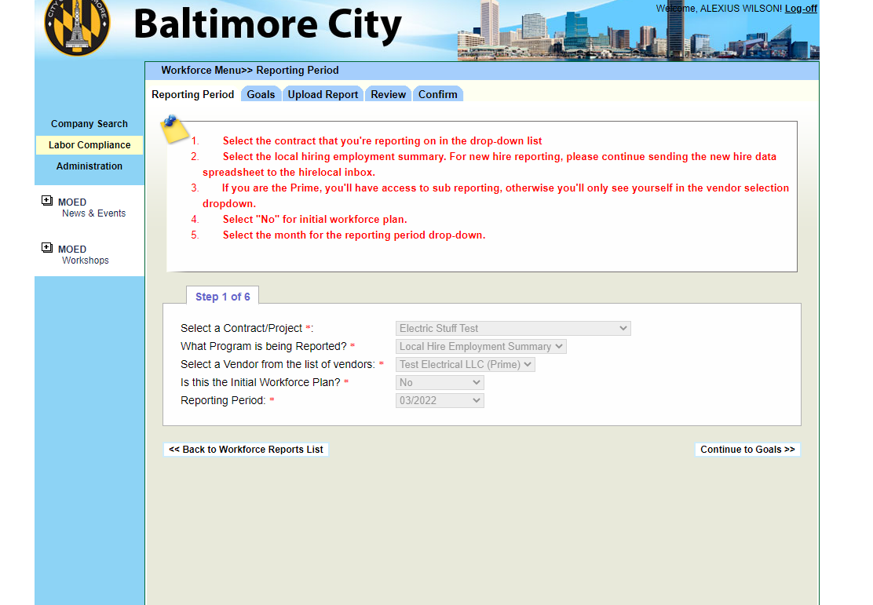

Step 12: The report just submitted should be listed in the grid.
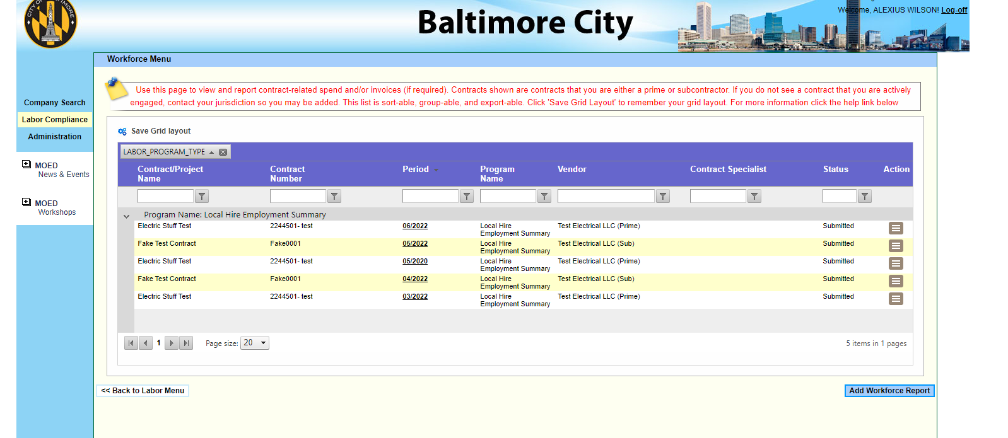

The monthly report is complete. Complete this report for any active contracts that are associated with you. Please log off the site which is located in the upper right corner of your screen. If you need additional assistance, contact hirelocal@oedworks.com with the subject line “Prism Assistance”. Please make sure to provide your business name and contract name or number in the email.

